**EEE361**

**ASSIGNMENT**

**SET-1**

1. An Electric field in air (Z $≥$ 0) with the component:

E = 10 sin (⍵t + 3z) ax V/m hits normally in a river surface at z = 0 as shown in fig 1. below. Suppose that the river surface is smooth and the ε = 80ε0, µ = µ0 in river, Find

* + 1. ⍵
    2. The wavelength of the signal in air
    3. The reflected E and H field
    4. The transmitted E and H field

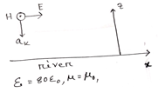

Fig: Problem 1

1. a) Explain with proper figures (in detail): In the Faraday’s electromagnetic equation (also known as Maxwell’s 3rd equation), why the sign of the time derivative is negative but the curl part (of electric field) is positive.

Also explain in detail (with proper figures): if the sign ‘were’ positive, what would happen!!!!

b) (i) calculate the divergence of this function: 25xyz + 19xy+ 30xz  
(ii) calculate the curl of this function: 25xyz + 19xy+ 30xz

(iii) Calculate the gradient of this function: 25xyz + 19xy+ 30xz

c) (i) In the primary circuit, why do we always use AC voltage source instead of DC voltage for real world applications?

(ii) Why do we use round shaped coils (I.e. Round shaped turns in the coils) in both the primary and secondary circuits [If those coils were not round shaped, what would be the problem]?

*** You should draw figures to make your explanations strong.

1. A source free ‘lossy’ region is a region, where there is no net charge and no current. Rewriting the Maxwell ‘s equations accordingly show that in a source free ‘lossy’ region, the wave equation becomes:

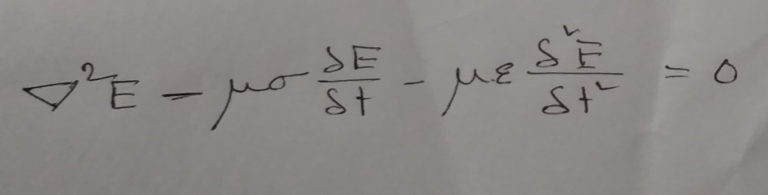

(ii) Given, $\overline{E}$ = 25 sin (2π×106 t – 6x) z V/m.

* Find direction of the propagation of wave
* Calculate time period, wave length, velocity
* At t = 0, T/8, T/4, T/2 sketch the wave shapes

1. In free space $E=20Cos\left(ωt-50x\right)$ ay V/m, Find:
2. Jd
3. H
$ω$

4. Suppose **E** fields and **H** fields are:

$$E = E_{0}e^{j\left(k.r-⍵t\right)}$$

$$H= H_{0}e^{j\left(k.r-⍵t\right)}$$

$Where$ k = kxax + kyay + kzaz and r = xax+yay+zaz

Show that $∇ × E = - ∂B/∂t$ can be expressed as K $×$ E = $μωH$ and deduce ak aE = aH

For the same fields:

Show that Maxwell’s equation in a source-free region can be written as

k.E = 0

k.h=0

k $×$ E = $μωH$

k $×$ H = $- μωH$

From these equations deduce ak aE = aH and ak aH = aE